Name : Anh Quoc Nguyen
Matriculation number : 1397466

RMS:
1. Taskset: { T1 (7, 24); T2 (1, 8); T3 (4, 14); T4 (3, 15) }
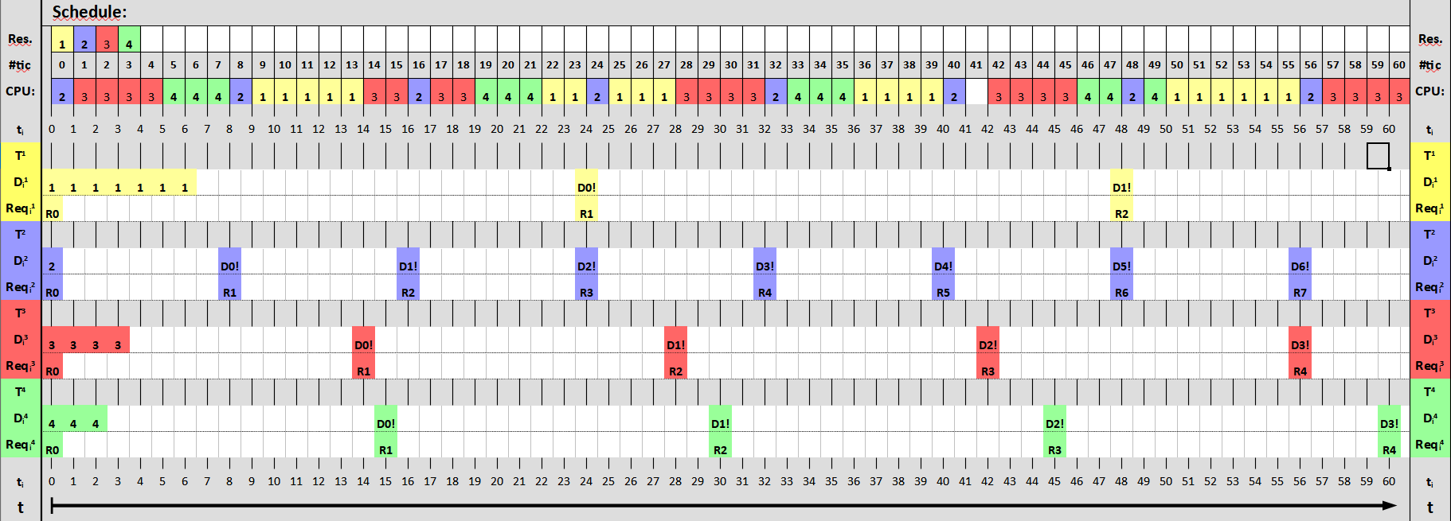
2. Taskset: { T1 (6, 20); T2 (3, 12); T3 (4, 10) }
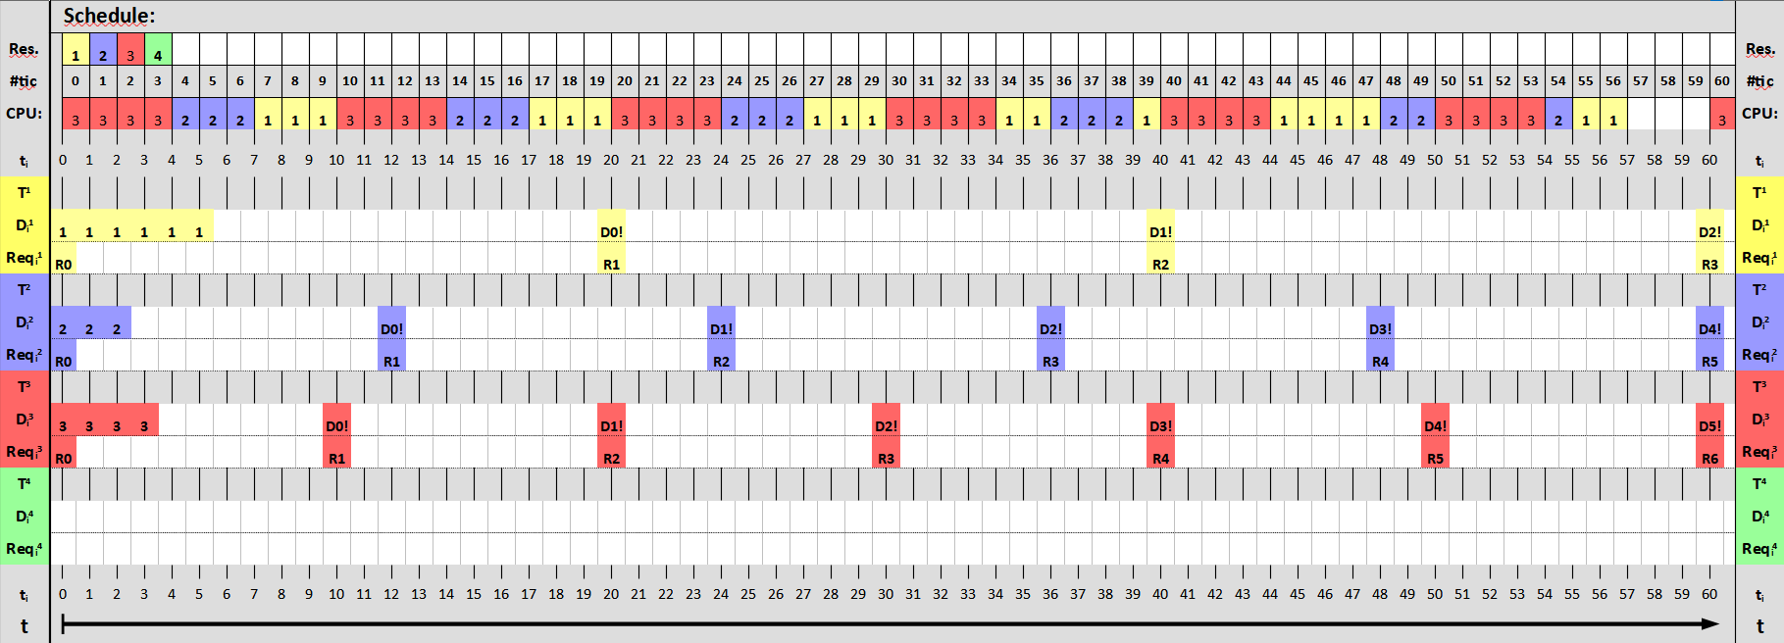

3. Taskset: { T1 (7, 20); T2 (3, 12); T3 (4, 10) }
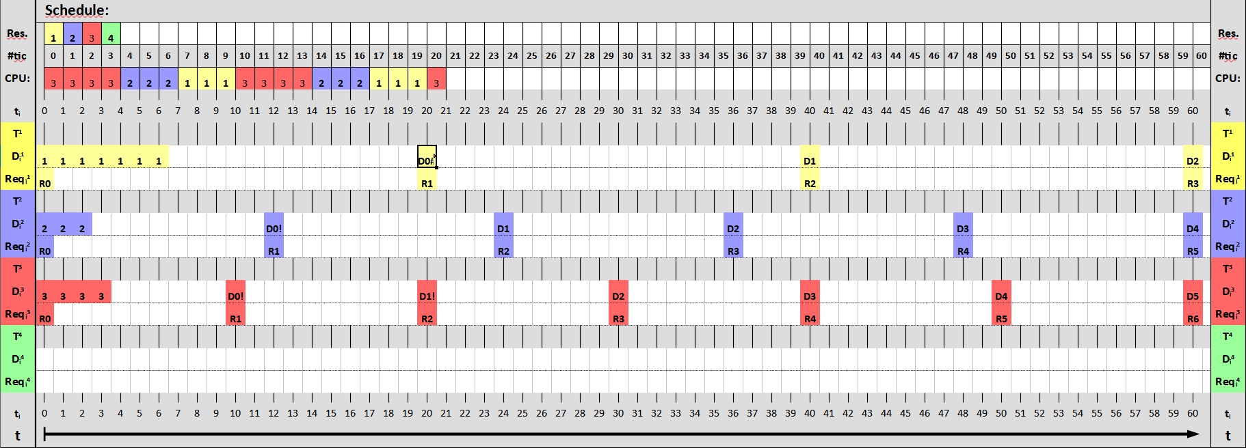
4) Calculate the load (each task and in total) of the systems:
Load of a task: Ui = ei/Di
1. Taskset: U = 7/24 + 1/8 + 4/14 + 3/15 = 379/420 ≈ 0.902
2. Taskset: U = 6/20 + 3/12 + 4/10 = 0.95
3. Taskset: U = 7/20 + 3/12 + 4/10 = 1

5) Do and document the schedulability tests for the systems
U ≤ n * (21/n – 1) n = number of periodic tasks

1. Taskset: 0.902 ≤ 4 * (21/4 – 1) → 0.902 ≤ 0.757
2. Taskset: 0.95 ≤ 3 * (21/3 – 1) → 0.95 ≤ 0.78
3. Taskset: 1 ≤ 3 * (21/3 – 1) → 1 ≤ 0.78

EDF:
1. Taskset: { T1 (1, 8); T2 (6, 22); T3 (3, 15); T4(4, 20)}
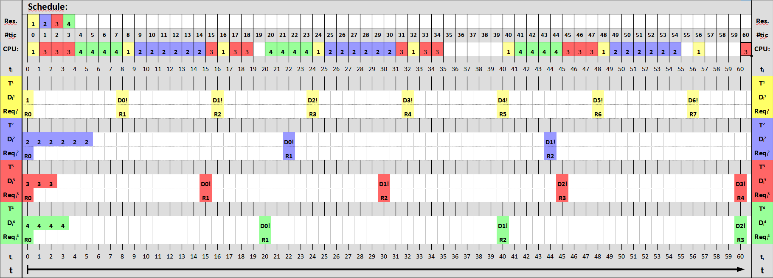
2. Taskset: { T1 (2, 10); T2 (4, 15); T3 (5, 12)}
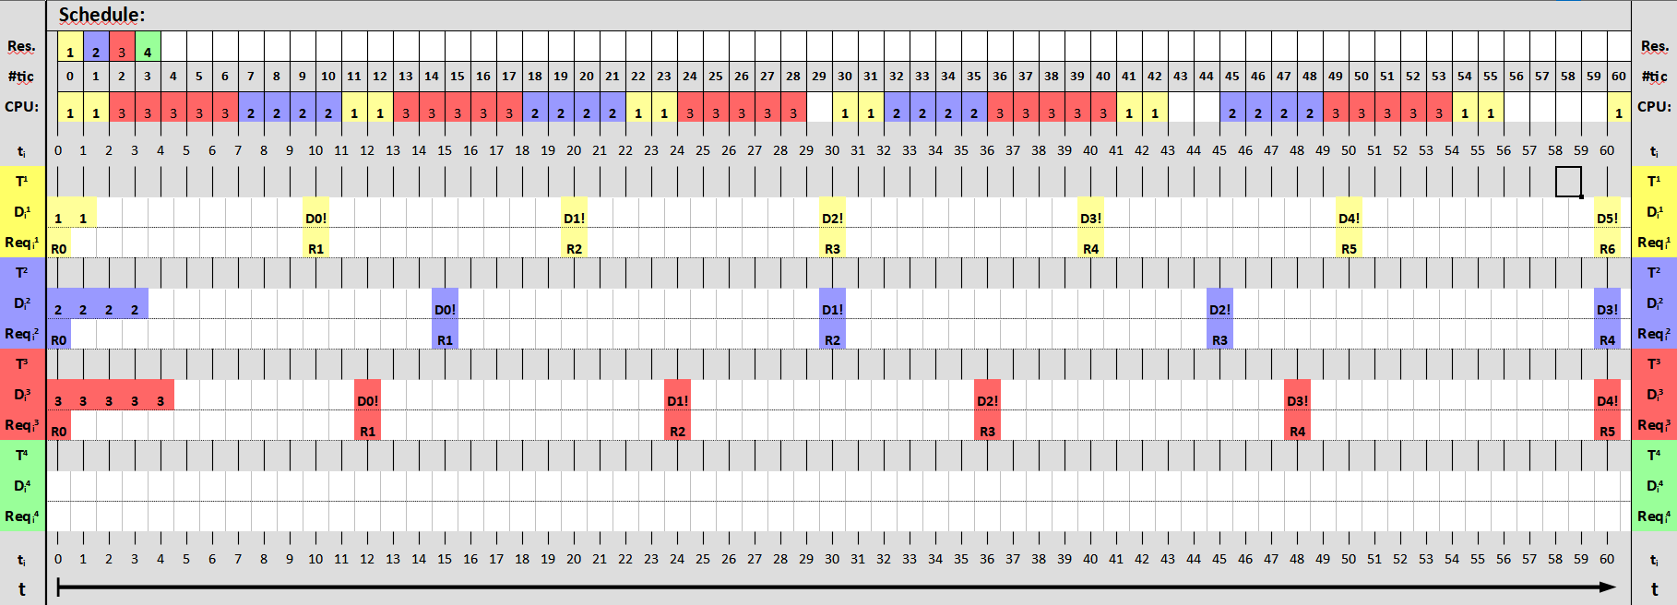

3. Taskset: { T1 (5, 12); T2 (2, 10); T3 (4, 15)}
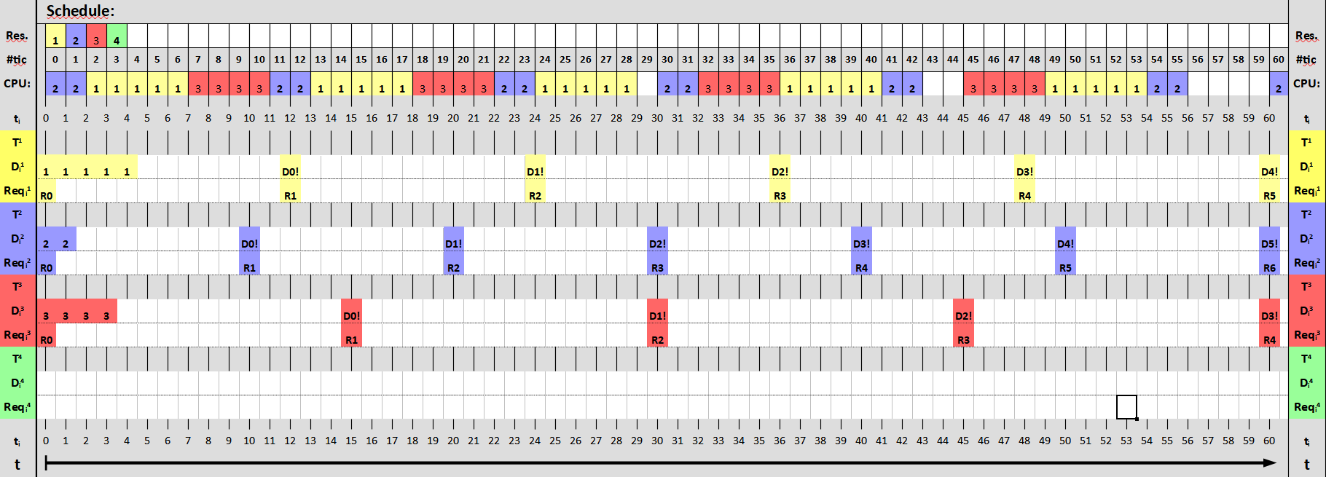
4) Do and document the (tow) schedulability tests for the taskset of 1 (as if you were using RMS).
Load of a task: Ui = ei/Di
System load: U =
Schedulability: U ≤ n * (21/n – 1) n = number of periodic tasks

1. Taskset: U = 1/8 + 6/22 + 3/15 + 4/20 = 351/440 ≈ 0.798
0.798 ≤ 4 * (21/4 – 1) → 0.798 ≤ 0.757
2. Taskset: U = 2/10 + 4/15 + 5/12 =53/60 ≈ 0.883
0.883 ≤ 3 * (21/3 – 1) → 0.883 ≤ 0.78
3.Taskset: U = 5/12 + 2/10 + 4/15 = 53/60 ≈ 0.883
0.883 ≤ 3 * (21/3 – 1) → 0.883 ≤ 0.78

